# Logo for National Disability Services (NDS)

Tasmanian Allied Health Workforce Supply Project  
Report on Allied Health Clinician Forum

Held at Campbell Town, 6th December 2017

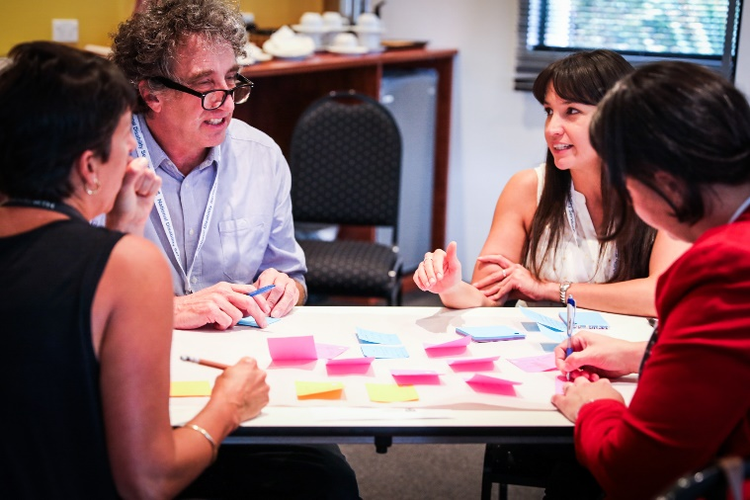 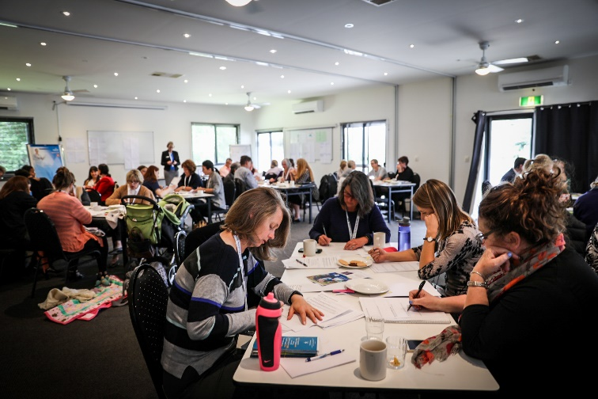

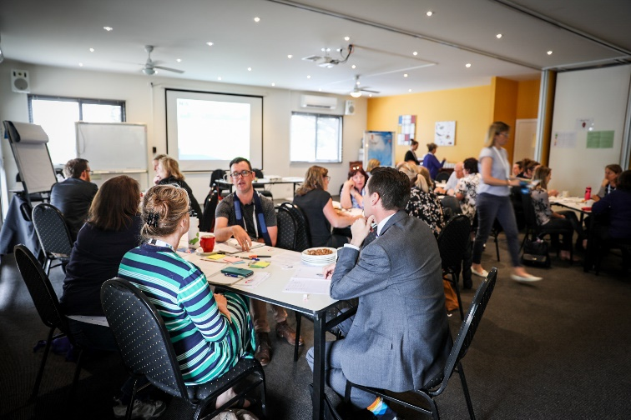 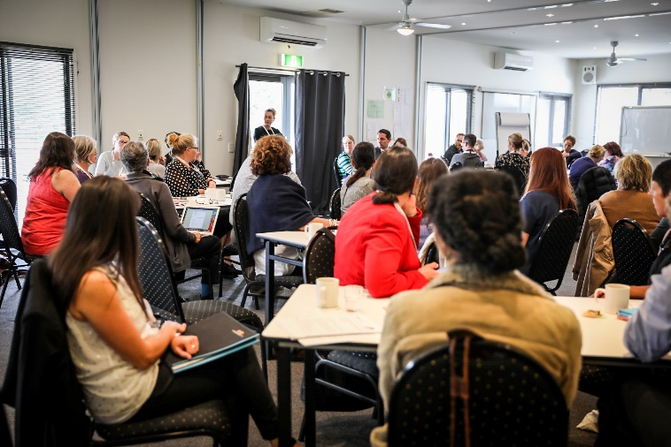

 Funded by the Australian Government Department of Social Services 

# Background

There is a shortage of allied health practitioners (AHP) to provide therapy supports to people with NDIS plans in regional, rural and remote Tasmania. This, in conjunction with the expected increased demand for disability services in the coming years, poses a significant risk to the successful roll out of the NDIS in these areas, potentially impacting the quality of life for people with disability and developmental delay.

NDS has received NDIS Sector Development Funding from the DHHS, to develop and implement strategies to address AHP shortages and to increase the capability of the AHP support workforce to better meet the needs of people with disability and developmental delay residing in regional, rural and remote areas of the state. The following project outcome areas were agreed:

* Retention rates for existing AHPs in regional/remote/rural areas will be maintained or improved
* New AHP and other disability support professionals/support workers will be attracted into regional/remote/rural areas
* Allied Health Assistant (AHA) traineeships will be established
* An Allied Health Disability Workforce Strategy for regional, rural and remote Tasmania will be developed

As part of the project, an Allied Health Clinician Forum was held to identify issues and solutions for AHPs working in the disability sector. It was one of several community engagement activities to inform project priorities and strategies. This report summarises the discussions and ideas generated at that Forum.

# How was the Forum run?

The Forum was designed around the following topics, identified through prior community engagement and the pre-defined project priority areas.

1. Issues being experienced by clinicians working in the disability sector
2. Continuing Professional Development (CPD) / training and networking
3. Telepractice
4. Workforce attraction – disability sector in regional rural and remote Tasmania
5. Use of allied health assistants in the disability sector

Each topic was addressed by a speaker who provided information on opportunities and background relevant to the topic at hand. Topics were then discussed in a workshop setting.

Attendees were asked to complete follow up forms indicating their region of work, organisation type, role, professional background, and NDIS involvement. These answers were then used to break the group up so that a mix of backgrounds were placed on each table for group work. Follow-up forms were also referred to throughout the day to gain further feedback.

A facilitator was placed at each corner of the room to assist with the completion of group activities.

Following the Forum, attendees were contacted via email to seek any further feedback, and provided with access to a Dropbox with summaries of their group work, as well as links and resources that were discussed on the day. See Appendices 1 and 2 for further details about how the Forum was promoted and run.

# Who attended the Forum?

A total of 53 people attended the forum, of whom 43 identified as AHPs. See further break down in the following tables.

Table Attendee summary by role

| Role | Number |
| --- | --- |
| Practicing clinicians | 35 |
| Clinicians & Managers | 3 |
| Managers / Directors | 7 |
| Education / Training | 2 |
| Workforce planning | 3 |
| DHHS / Policy / NDIA | 3 |

Table Attendee summary by organisation type

| Organisation Type | Number |
| --- | --- |
| Government | 32 |
| Private practitioners | 6 |
| Both government & private | 2 |
| Not for profit | 11 |
| Not reported | 2 |

Table Attendee summary by region of work

| Region of work | Number |
| --- | --- |
| State wide | 13 |
| Northern Region  (East Coast) | 16 (3) |
| North West | 7 |
| South | 14 |
| Interstate | 1 |
| Not reported | 2 |

Attendees worked in a variety of roles and regions but there was a strong skew towards government employees who made up 32 of the 53 attendees. At least 10 private practitioners contacted NDS to express their desire to attend but were unable to afford a day away from their clinical practice. Several of these had previously met with project coordinator during community engagement outreach visits to provide input and direction to the project.

Twenty seven attendees reported they are providing services funded through NDIS plans, just over half of whom are employed in government roles (Disability Assessment and Advisory Team (DAAT) and Tasmanian Health Service (THS) clinicians).

The only professions not represented on the day were exercise physiologists and art/music therapists, a breakdown of AHP types represented is provided in Figure 1 below:

Figure AHP role breakdown (43 forum AHP attendees)

Occupational therapists 37%
Dietitians 9%
Orthotist and prosthetist 3%
Social workers 7%
Psychologists 14%
Physiotherapists 9%
Speech pathologists 16%
Podiatrists 5%

Clinicians working with early childhood, school aged, and adult client age groups were all represented at the Forum, a breakdown is presented in figure 2 below.

Figure AHP client age group breakdown (35 practicing clinician forum attendees)

Early childhood 6%
School aged 3%
Adult 26%
Early childhood and school aged 8%
School aged and adult 26%
All ages 31%

Overall the forum achieved broad representation of AHPs working in the disability sector in Tasmania, with a skew towards government workers. This is in part due to those in private practice having difficulty getting away from their practice as described above, and in part due to the fact that a significant proportion of AHPs in the Tasmanian disability sector are currently employed in government roles.

# Findings

## Issues being experienced by clinicians working in the disability sector

Forum attendees were provided an opportunity to name up the issues they feel most need to be addressed in order to strengthen allied health services for people with disability and developmental delay in rural and remote areas of Tasmania.

These issues were compared against all of those unearthed in project consultation, and common themes were developed, see Appendix 3 for a full breakdown of these. A summary of themed issues as reported by attendees is shown in the table below.

Table Reporting of issues against themes (organised by frequency of reports, high to low)

| Issue theme | Number |
| --- | --- |
| Difficulty navigating the NDIS | 34 |
| Lack of allied health service availability for people with disability / developmental delay in rural and remote areas | 26 |
| Difficulty with recruitment and retention of AHPs in the disability sector in Tasmania (state-wide) | 18 |
| Lack of support for effective working relationships between AHPs and disability support workforce | 18 |
| Fragmentation of allied health services due to NDIS implementation | 12 |
| Lack of support for transport / travel to allied health services | 12 |
| Lack of access to CPD and training for AHPs in disability sector & difficulties with access due to billable hours demand under the NDIS | 11 |
| Available allied health services aren’t always person centred or appropriate for people with disability and developmental delay | 9 |
| Gaps in allied health service delivery (specialised skill sets, service for certain age groups, lack of data surrounding this) | 8 |
| Poor infrastructure and skills in use of technology (AHPs, participants, disability support workforce) | 6 |
| Lack of appropriate supports for behaviour management | 5 |
| Lack of knowledge on AHPs’ role in supporting people with disability and developmental delay (for everyone involved other than AHPs) | 5 |
| Lack of information about allied health service availability | 3 |

Issues surrounding the navigation of the NDIS was clearly the strongest theme on the day, and was reported by a range of government, private and not for profit employed AHPs.

“NDIS needs a viable profitable model if they want private providers to enter the space - realistic hours, make it easier to register, better communication, decreased need for plan review”

“(I need help) understanding the grey areas between health and disability”

Other strong themes included the lack of allied health service availability for people with NDIS plans in regional rural and remote areas; difficulties with recruitment and retention of AHPs in the disability sector and a lack of supports for establishing effective working relationships with the disability support workforce. These, and other issues reported, are discussed in more detail in the following sections of the report where relevant.

## CPD / training and networking

As shown in table 4 above, a lack of support for the development of skills to work in the disability was reported as a significant issue. This was raised not only for those new to the sector, but for more experienced professionals wishing to develop or maintain specialised disability relevant skill sets.

“Skills are lacking in disability”

“(There is a) lack of mentorship for less skilled clinicians, those new to disability”

Attendees identified over 60 ideas for CPD for AHPs working in the disability sector, they then voted for their top 5 ideas.

The most popular CPD topic themes were (in order of votes received):

1. NDIS supports and information
2. Disability awareness & person centred practice
3. Behaviour supports
4. Telepractice
5. Business supports

Figure 3 below provides an overview of the number of ideas per topic theme, and an indication of popularity based on votes cast on the day.

Figure Summary of CPD topic themes (with number of ideas and votes received)

Management 1 idea, no votes
Goal Setting and outcome measurements 2 ideas, 2 votes
Working with support workers 34 ideas, 3 votes
Clinical - assistive technology 2 ideas, 4 votes
Clinical - general disability PD topics 5 ideas, 4 votes
Networking and mentoring 5 ideas, 9 votes
Business supports 6 ideas, 11 votes
Telepractice 3 ideas, 12 votes
Behaviour supports 11 ideas, 13 votes
Disability awareness and person centred practice 15 ideas, 13 votes
NDIS support and information 7 ideas, 14 votes


Support and information surrounding the NDIS was the most popular topic for CPD and training, this is unsurprising given that difficulties with navigating the NDIS was also the most prevalent issue reported.

Professional networking and use of mentoring for clinical support emerged as a topic in its own right, as well as a common choice for the mode of delivery of PD. This is likely reflective of the reported fragmentation of allied health services as a result of NDIS implementation.

“NDIS framework is leading to the fragmentation of service provision & decreased coordination of services”

“Support is required to develop consortia & skill sharing rather than seeing others as competition”

A full list of CPD topic ideas and details is presented in appendix 5.

## Telepractice

Telepractice is the delivery of therapy and assessment at a distance through the use of technology. It can be used as one way to deliver timely therapy supports, particularly when travel to or from services is difficult or not possible. A lack of support for, and access to transport was a commonly reported barrier throughout project consultation. It was also well represented in the issues reported by forum attendees. The delivery of therapy services via telepractice could be seen as one possible way to address this issue.

Overall there was strong interest from AHPs in the use of telepractice to improve therapy reach to people with disability and developmental delay in all areas of the state.

“I live in a rural area and this would be a great service to offer”

“Telepractice has application in high population centres to facilitate initial contact & aim for more frequent and meaningful contact with clients and families”

“I have no experience in using telepractice, it seems like a good option to provide more services to a wider community”

Of the 39 AHPs who gave feedback on this, three-quarters expressed that they would like to receive further support and information on how telepractice can be applied in the provision of therapy services, particularly practical support to use technology and understand security processes. To add further weight to this, telepractice ranked 4th out of 11 categories of CPD ideas contributed by attendees.

“(I need) practical support to give it a go!”

Poor infrastructure and skills in use of technology was represented in the issues recorded by attendees. A number of clinicians raised concerns around the lack of appropriate infrastructure to support telepractice, including poor internet connections in rural and remote areas, and the need for more support to be provided to clients and their support team in adopting technology.

“Whilst useful, it's challenging at times to book a room (and there are) confidentiality and organisational issues” (government employee)

Several clinicians volunteered their own examples of telepractice use in the clinical setting, including one who reported using a Go Pro (a small camera worn by the client that fed the image back to a computer where the AHP was remotely based) to walk a client through a home assessment before meeting them in an outpatient appointment, in order to adequately plan for their therapy and follow up.

Clinicians tended to agree that there is a need for a balance between providing a quality service vs. no service at all, and that in some instances telepractice would not result in better clinical outcomes.

“Minimal limited benefit to my clinical practice, face to face in home more productive”

“Some use in general interviews …No use in behaviour observations at school/home”

Overall there appears to be strong support for the use of telepractice in certain clinical settings, however there is a need for practical support and training in ordered for it to be adopted by AHPs.

## Workforce attraction – disability sector in regional rural and remote Tasmania

Thirty six of the 43 AHPs attending the forumreported theyattained their undergraduate degree outside Tasmania, and nearly two-thirdsmoved to Tasmania for the first time after they had completed their undergraduate degree.

This is likely to be typical of the general AHP cohort in Tasmania, since undergraduate training for the some of the most common allied health professions (Speech Pathology, Occupational Therapy, Podiatry and Physiotherapy) is not available in Tasmania.

Of the AHPs who moved to live and work in regional rural or remote Tasmania for the first time (defined as anywhere outside of Hobart LGA), almost all (23 out of 25) had already worked in regional or rural/remote areas prior to their move. These AHPs provided further information about their transition to regional or rural/remote work, see appendix 4 for details.

Attendees were given the following potential workforce groups to stimulate discussion and help generate ideas around regional rural and remote disability sector workforce attraction:

* New graduates
* Skilled ex-Tasmanian clinicians who might return
* Tasmanian school-leavers who might study allied health
* Experienced clinicians moving across into sector

The following themes emerged in the discussions that followed. See appendix 6 for a breakdown of ideas by target cohort.

### Training and CPD

A lack of clinical and CPD opportunities was listed as one of the key challenges, and was also well represented in the overall issues reported by attendees. Many AHPs felt addressing this may also go some way to improving retention of AHPs in the sector.

“Training and education is difficult to access for potential allied health staff that live in rural areas”

A number of attendees felt that financial assistance should be provided to access CPD for clinicians new to the sector, and could also be an incentive for more experienced clinicians to take up work in Tasmania.

Several groups raised that advocacy is required for the establishment of Tasmanian undergraduate allied health degrees for those professions most in demand. One idea included the establishment of a satellite rural school to be attached to a mainland university, similar to those in rural Victoria.

### Financial and infrastructure incentives

Cost of relocation was frequently reported as a challenge. Ideas to alleviate this included offering financial incentives such as discounts for flights to see family and relocation assistance.

The lack of infrastructure such as poor Internet connection, as well as a lack of information about service availability was also a recurrent theme. Ideas to address this included working on improving internet access, and providing newcomers with an information pack/register of what is available in their area.

“Development of local infrastructure to make the area more attractive”

Access to telepractice for clinical work and also as a way to access professional supervision was listed as a possible option to incentivise those choosing to work in more rural and remote areas.

Many of the ideas to attract new workers into the disability sector were aimed at addressing perceived uncertainty with income with the changes in the disability sector. Small business grants, rural and remote loading, and housing and childcare subsidies were just some of the ideas attendees came up with to attempt to address this.

“Finding somewhere that would pay a reasonable wage for very experienced staff” (difficulty reported by AHP with move to rural Tasmania).

Bonded scholarships were suggested as an incentive to attract more Tasmanian high school leavers to pursue undergraduate allied health studies, given the difficulty they might experience in relocating to the mainland to attain their undergraduate degree.

### Networking/Supports

The development of more robust professional networks and mentoring relationships frequently arose, not only as a way to support newcomers to the disability sector, but to support those already in the sector to remain.

“Stronger professional networking opportunities”

Some ideas surrounding this included: establishing links with centres of excellence on the mainland, re-establishing Tasmanian representatives for allied health professional associations, and fostering the development of mentoring relationships.

“You're not a local until your grandmother was born there”

Establishing new social networks were also listed as a key challenge. Accordingly, this came up as a factor in the attraction and support of new professionals into the sector. This theme was particularly strong for supporting allied health students and new graduates.

### Exposure and opportunity

It was suggested that more effort should be made to expose young Tasmanians to the disability sector and allied health career opportunities. Some ideas for this included volunteering and casual work opportunities in the disability sector, allied health professional representatives to attend careers days, and work experience placements.

Increasing exposure to the disability sector during allied health undergraduate degrees was noted to be of importance. An idea was also raised around bringing undergraduate students on a fun ‘getaway’ weekend to Tasmania where they might be able to explore what the Tasmanian lifestyle has to offer and be introduced to career opportunities in the disability sector.

Overseas sponsorships were also raised as an option to recruit both new graduates and skilled clinicians into the Tasmanian disability sector.One manager of a clinical team reported good success with overseas recruitment with the assistance of a local recruitment agency.

### Marketing

Selling the Tasmanian lifestyle emerged as a strong theme in the recruitment of new professionals into the sector, given that many clinicians would need to move from the mainland having completed their degree there.

“Advertise the benefits - beautiful areas, services available”

The Tasmanian lifestyle and associated benefits such as improved work life balance, strong sense of community, the beauty of the natural environment, housing affordability, and ability to own land were commonly listed as attractors/positives and these could also be used to ‘sell’ the opportunity to others.

“The lifestyle, reduced commute/stress, I found so many interests and had time to pursue them, housing affordability” (a list of benefits reported by AHP who made the rural transition)

One group came up with the idea of targeting mature age clinicians looking towards retirement, for an ‘encore’ career, to fill gaps in more regional rural and remote areas. Some AHPs also reported that this is something that might entice them, or what bought them to Tasmania.

It was also suggested that early engagement is key for attracting school leavers to study allied health, as many school leavers may not even be considering university let alone an allied health career.

### Student placements

A positive experience on student placement was acknowledged as key in attracting new AHPs into the disability sector, however almost all AHPs indicated this is difficult due to the NDIS funding model and the changes that are taking place in the sector. Whilst just under two thirds of AHPs indicated their organisation currently supports allied health students, almost all of these are working within THS, or within DAAT teams which are not continuing beyond mid-2018.

The only identified not for profit disability provider that supports allied health student placements report they may cease this soon due to restrictive funding and less flexibility under NDIS funding.

A number of sole providers and new allied health private practices reported they cannot support students due to financial and resource restrictions. However, approximately half stated they would take on students if they received financial support to do so, this aligns with pre forum engagement findings.

“Having a student reduces my income - there should be a financial benefit for providing placements. I could share with another OT as I don't feel can provide enough hours” (sole provider)

“I would like to but (I am a) sole clinician … NDIS funding will make this challenging”

University of Tasmania whole of community facilitators provide supports to students and AHPs surrounding student placements currently. However a University representative acknowledged that funding is not available to compensate clinicians and they are having limited success in placing allied health students in general, and rarely outside of THS.

### The need to target efforts to areas of need/demand

There was a call for better use of data and improved communication around existing gaps in services so that recruitment efforts can be directed towards the areas of highest need.

“You have to promote the areas of need”

The skills, values and attributes of prospective clinicians entering the sector were also noted to be of importance, with a call to target recruitment strategies to those best suited to the role/sector, this could apply to school leavers looking to study allied health, undergraduate allied health students, and more experienced clinicians looking to move across into the sector.

## Use of Allied Health Assistants (AHAs) in the Disability Sector

This topic area drew the most vigorous response from AHPs, with opinions broadly ranging from complete rejection, to full and enthusiastic support for the use of AHAs to spread the reach of therapy supports for people with disability and developmental delay.

A lack of supports to develop effective working relationships between AHPs and support staff such as AHAs and disability support workers (DSWs) also rated highly amongst the issues reported.

“We need to ensure access to appropriately trained AHAs and DSWs”

“There is a lack of basic skills and knowledge of DSWs & DSOs (disability support organisations) who are responsible for implementing our strategies/providing direct support to participants”

Of those AHPs who provided feedback, just over a thirdare currently working with AHAs. Almost all of these came from within THS, one from the education department, and from one large disability not for profit provider. This aligns well with pre forum engagement findings, there is limited use of AHAs in the disability sector currently.

Furthermore, of those AHPs that don’t currently work with AHAs, only 8 out of 19 indicated they would be interested in working with AHAs in the future, most with the caveat that much remains unclear in their role and work needs to be done to unpick this further. Barriers raised included the lower rate of pay for an allied health assistant as compared with a disability support worker.

“I would like to understand the viability of a model that uses AHAs more - at the current rate this seems unlikely”

Concerns were also raised around the governance and quality assurance of introducing this new role into the sector.

“(With the introduction of AHA you are) adding additional complexity in already unstable market”

“Legal liability issues re responsibility between sole practitioner AHPs and AHAs not directly employed by them”

“I am concerned that not enough attention will be paid to establishing well-structured services… I don't think it is enough to expect that 'good relationships' will be established between the service providers and consultant AHPs who are not employees of the service”

### AHA role delineation

AHPs were asked to complete an activity aimed at delineating clinical tasks into either: AHP only, AHA with close supervision, and AHA independent/distant supervision. Most were able to come up with a variety of tasks that would be appropriate to delegate to AHAs. See appendix 7 for a full breakdown of tasks and ideas. Some extra benefits for the use of AHAs that came up during group discussions included:

* Health literacy – increase community knowledge of health
* Communication with community members regarding available services
* Helping clients navigate NDIS
* Local contact – set up technology, facilitate communication

### AHA Supervision and Delegation Frameworks

AHPs were asked to identify what they feel would be needed in order to be able to work effectively with AHAs in the disability sector, the following themes emerged.

* Frameworks
* Supervision
* Delegation
* Scope of Practice
* Competencies
* Quality Assurance and risk management

See appendix 8 for a full break down of information under each theme area.

# Summary

The Allied Health Clinician Forum was well attended and achieved broad representation of AHPs working in the disability sector in Tasmania.

It is clear that AHPs in the sector are struggling to manage the changes and challenges that have come with the NDIS implementation, as issues with navigating the NDIS dominated those reported on the day.

Allied health practitioners have expressed significant uncertainty around the financial and career sustainability their work within the sector. This is felt particularly acutely by those who are facing the move from long standing government teams into the private or not for profit sector.

Significant issues were also reported in the areas of recruitment and retention of AHPs in the disability sector in general, particularly in more rural and remote areas. The funding model of the NDIS is currently seen as a barrier to supporting skills development for new professionals.

Providing opportunity and exposure to the disability sector through initiatives such as: supporting student placements; marketing the Tasmanian lifestyle to mainland AHPs; early engagement with school leavers; and the establishment of local undergraduate university courses were just some of the ideas raised to assist with recruitment of new professionals. There was also a call for more clarity on areas of demand and gaps in service delivery, in order to best direct efforts in this area.

There is strong support for the development of allied health disability professional networks and training opportunities for both existing and new AHPs in the sector, particularly in the areas of NDIS information sharing and support, disability awareness & person centred practice, behaviour supports, telepractice and business supports. This could also be one way forward in addressing the perceived fragmentation of allied health service delivery as a result of the NDIS framework.

There is broad recognition of the need to extend therapy reach to people with disability and developmental delay in more rural and remote areas of Tasmania, and enthusiasm around the use of telepractice to achieve this when appropriate (with the proviso that practical support is provided).

The need to strengthen relationships between AHPs and the disability support workforce is acknowledged, however significant barriers exist to the development of an AHA workforce. It is clear that further groundwork is needed to support the role of AHAs in the disability sector.

# Next steps

The Clinician Forum findings will be used to inform the development of a Tasmanian Regional Rural and Remote Disability Allied Health Workforce Strategy and Action Plan, along with findings from Community Forums. This will allow the prioritisation and implementation of project activities until project end (end of June 2018), and application for further funding to extend project activities.

The workforce strategy and action plan will be shared with forum attendees and key project stakeholders in early 2018, with encouragement to contact NDS to provide feedback.

# Appendices

## Appendix 1: Forum promotion

The forum was promoted via the following networks and contacts in the preceding three months:

* Representatives of all allied health professional associations
* Project reference group members including DHHS, St Giles, NDIA, Primary Health Tasmania, Speech Pathology Australia and Australian Physiotherapy Association representatives
* Contacts through community consultation in Burnie Smithton, Huon Valley, Smithton and Scottsdale including individual clinicians and local service provider networks.
* Tasmanian Allied Health Network (via Primary Health Tasmania)
* Oral presentation at Tasmanian Allied Health Symposium (10/11/17)

## Appendix 2: Structure of the day

### Issues being experienced by clinicians working in the disability sector

Attendees were provided time at the start of the session to answer the following question:

‘Please list the issues you feel need to be addressed in order to strengthen allied health services for people with disability and developmental delay in rural and remote areas of Tasmania’

They were then provided time at the end of the day to review issues, and add more if they wished.

### CPD / training and networking

Presentations:

* HR plus - rural health workforce scholarship opportunity
* Kristen Foss - update on NDIS Quality and Safeguarding framework
* TASCOSS - NDIS expert panel grant opportunity
* Case study - ACT Allied Health workforce Project in which numerous strategies stemmed from issues that clinicians were experiencing in the disability sector
* Review of free disability resources, including the National Disability Practitioners allied health hub

Activities:

* Table groups provided with blank calendars and asked to develop their ideal CPD calendar, with details on topic, mode, audience and presenter.
* Instructed to consider numerous audiences including: experienced and new clinicians, varying client age groups, regional/remote clinicians as well as urban based.
* Calendars were displayed and attendees were given the opportunity to vote for the best ideas.

#### Telepractice

Presentations:

* Kim Bulkeley – presentation on use of telepractice in disability sector & research overview
* Telepractice guidelines provided for attendees to view
* Provided brief intro to ACD/Speak out sector development fund project, opportunity for clinicians to trial free virtual meeting rooms.

Activities:

* Group discussion surrounding ideas for use of telepractice
* Follow up form - interest in telepractice

#### Workforce attraction – disability sector in rural and remote Tasmania

Presentation:

* University of Tasmania (UTas) whole of community facilitator – brief discussion regarding student placement supports

Activity:

* Individual worksheet - information gathering on living in regional rural and remote areas
* Group activity - brainstorm supporting/attracting AHPs in the disability sector:
* Follow up form – student placements

#### Use of allied health assistants in the disability sector

Presentation:

* Kim Bulkeley – overview of research and stories on use of AHAs in the disability sector, including supervision and delegation frameworks

Activities:

* Group activity: AHA role delineation
* Group discussion: issues and ideas for use of AHAs
* Group activity: supervision and delegation framework, what do you feel you need in order to be able to work effectively with an allied health assistant in the disability sector?
* Follow up form – use of allied health assistants

## Appendix 3:Issues for AH service delivery in Tasmania for people with disability and developmental delay

Table Issue themes and breakdown

| Issue | Break down |
| --- | --- |
| Difficulty with recruitment and retention of AHPs in the disability sector in Tasmania (state-wide). | * Difficulty attracting new professionals into the disability sector   + NDIS funding model not allowing for training/support of new professionals including student placements and new professionals entering the sector   + Lack of Tasmanian undergraduate degrees in SP, OT, PT, O&P and Podiatry * Attrition of existing AHPs who work in government teams, not willing to take risk of starting new business or willing to take lesser pay at not for profits * Lack of recognition of AHPs with higher skills levels/more experience in NDIS pricing (lack of clinical career path/progression), which means there is less incentive to remain in sector compared with other areas such as the health sector |
| Lack of allied health service availability for people with disability and developmental delay in rural and remote areas | * Sense of isolation reported by people with disability and their families living in rural and remote areas, expressed in terms of connectedness to services and supports   + Visiting providers are infrequent and irregular = poorer access and longer wait times for people in more geographically isolated areas   + General lack of choice of providers who are based locally, some community members have expressed a preference for local providers where that option exists   + Visiting providers don’t understand the context in which they are working * AHPs not willing to live and work in rural and remote areas for a variety of reasons including lack of stable employment options and services * Thin markets – regular outreach not viable for therapy providers due to insufficient funding and resources available * Poor links between visiting providers and local supports |
| Gaps in allied health service delivery | * Poor data and clarity around where the demand and need is, in order to best direct service delivery * Less allied health services available to school aged and adult people with disability * Specialised skill sets such as paediatric physiotherapists often not available or limited to urban areas |
| Difficulty navigating the NDIS | * Poor understanding the concept of the NDIS and processes involved – service users, AHPs, disability support workforce, general community and other service providers such as health and education * Perceived lack of communication from NDIS regarding processes and changes * Delays and issues with payment for services reported by service providers. * Complicated planning and implementation processes, increased admin and wait times reported by both service providers and service users * Poor accuracy of plans, planners/Local Area Coordinators (LACs) & Early Childhood Early intervention (ECEI) partners failing to understand context of person with disability or developmental delay * Lack of clarity on interface between NDIS and other services, particularly education and health, and what NDIS will fund * Difficulty with registering new providers |
| Available allied health services aren’t always person centred or appropriate for people with disability and developmental delay | * ‘Medical model’ not fitting with social model of disability * Lack of governance for quality of services particularly private providers new to the space * Concerns around vulnerable clients not receiving good quality therapy supports * AHP not understanding the concept of capacity building for clients * AHP not understanding context of participant’s life * Organisational culture and structure of AH services not always supporting person centred service delivery |
| Fragmentation of allied health services | * Loss of larger multi-disciplinary government disability teams (in progress with disbandment of DAAT teams and possibly Early Childhood Intervention Services), proliferation of small and sole providers, resulting in loss of professional networks for skills sharing and collaboration * Loss of information history when client leaves a service * NDIS framework leading to decreased coordination & fragmentation of services.   + Complex/more vulnerable clients are not funded at appropriate levels |
| Lack of appropriate supports for behaviour management | * Not enough training for provision of Positive Behaviour Supports   + AHPs, DSWs, AHAs, carers/families, disability service provider managers * Poor awareness, management and reporting of restrictive practices |
| Lack of access to CPD and training for AHPs in disability sector | * Billable hours requirements under NDIS funding model not allowing for release time for CPD and training required for AHPS to work effectively in the sector * General lack of training/CPD availability for regional rural and remote AHPs * Lack of disability specific CPD/support availability for both new and more experienced AHPs in the Tasmanian disability sector. * Disability specific clinical information and resources are difficult to find/poorly coordinated |
| Lack of support for effective working relationships between AHPs and disability support workforce | * Poor communication and collaboration between AHP and support staff due to a number of factors including insufficient time, inappropriate models of practice & relationships. * Lack of staff and high turnover of disability support workers (DSWs), NDIS funding model does not allow AHPs time/flexibility to manage issues with this. * Poor training and literacy levels of DSWs, impacting on their ability to implement therapy recommendations * Fear from AHPs surrounding the inappropriate use of allied health assistants (AHAs) – going beyond scope poor quality of services. * Time for training and supervising AHAs and DSWs is not funded adequately, inadequate risk management for liability and legal issues when delegating tasks |
| Lack of information about allied health service availability | * People with disabilities and developmental delays and families and carers, LACs, ECEI partners, support coordinators & other AHPs * Information is fragmented and difficult to find |
| Lack of knowledge on AHPs’ role in supporting people with disabilities and developmental delays | * Families and carers, people with disability, LACs, ECEI partners, support coordinators * Results in therapy need not being recognised (not referred) or poorly directed referrals to allied health services |
| Lack of support for transport/travel to allied health services | * Cost and time involved is not funded * Increased pressure on families and services |
| Poor infrastructure and skills in use of technology | * Poor internet connection in rural and remote areas * AHPs, people with disabilities/families/carers, disability support workforce not skilled in use of technology * Lack of existing infrastructure and skills for use of telepractice options for delivery of therapy supports |

## Appendix 4: Individual worksheet summary – living in regional/rural/remote areas

### Regional/rural/remote positive aspects

* Lifestyle
* Family – connection to family/good place to bring up kids
* Work opportunity
* Sense of community
* Natural environment
* Space and affordable housing
* Followed partner
* Quieter/less traffic
* Role development/career opportunities not avail in urban areas

### Difficulties with transition

* Distance from family
* Difficulty finding information about services/options in area
* Lack of local services
* Break in to local community
* Limited job opportunities
* Long commutes if traveling to urban centre for work
* Access to clinical and professional support networks
* Cost of moving

### Ideas for easier transition

* Discounts for flights to see family
* Moving costs assistance
* Internet access, better access to technology for supervision
* Family friendly workplace
* Information pack/register of what is available in the area
* Telepractice
* Social networks- put in contact with other newcomer

### Appendix 5: Full list of CPD topic ideas with target audiences, modes and presenters.

Table Summary of CPD topic ideas

| Topic idea/s | Audience | Mode | Presenter |
| --- | --- | --- | --- |
| Regular/accurate updates for AHPs working within NDIS | All NDS registered AHPs | Email, website – page specific to AHPs? | NDIA |
| Understanding Disability reform / NDIS changes | All Tasmanian AHPs | Choice of webinar and short workshops with simple resources and how to guides | Champions in the field |
| Understanding NDIS processes:   * Registration * Bookings * Portals * Payments | All NDIS providers | ? | ? |
| NDIS linkages – advocacy for access, support and troubleshooting | Hospital workers, social workers, discharge planners, anyone who interacts with people who might access NDIS | Face to face | NDIA or Baptcare / Mission Australia (NDI partners) |
| Self-care for professionals working within NDIS | All NDIS AHPs | ? | Interstate presenter |
| Client rights   * Dignity of risk * Guardianship & administration board | AHPs AHAs and DSWs | Recurrent monthly forum | Suitably qualified AHPs  Senior Practitioner |
| Facilitating Communication and working effectively with people with intellectual disability | Business providers servicing people with disability, extended community | Face to face workshop, person focussed with ongoing support | Advocacy organisations |
| Person Centred Active Support | AHPs, DSW, NDIS access team/LACs | Webinar, connect to local person | Every moment has potential resource |
| Family partnerships model | Parents / carers | Train the trainer | Those already trained in FPM |
| Shared decision making | AHPs | Multimodal | people with disability / advocacy organisations |
| Disability Basics / 101 | New to sector | Online Resource | ? |
| Ageing well with disability / transition from paediatrics to adults | AHPs all people working with people with disability | Online or workshop | Experienced Clinician |
| Impact of physical disability | New to sector/DSWs/AHAs | Face to face and webinar | Experienced clinician |
| Communication with those that use communication devices | All people who work with the population | Face to face and webinar | Experienced clinician |
| Mental health and wellbeing for people with disability | Support staff / AHA | Mentoring for new staff | Experienced clinician |
| Autism awareness | DSWs | ? | ? |
| Positive Behaviour Support Planning   * Environmental interventions * Eating behaviours in disability (Dietetics) * BSP-QE-II * Complex behaviour needs/dual diagnosis * Restrictive practices * Level 1 basics, Level 2 train the trainer | Mix of AHPs, support staff/AHA depending on topic  Level 1 for new to sector / new graduates  Level 2 – experienced clinicians | Online webinars  Massive open online text  Weekends/evening seminars and workshops  Mentoring  Competency based | Professional associations  Behaviour specialist  Discipline specific experts  DAAT team members  Senior practitioner |
| Telepractice – practical ‘how to’ training | AHPs  AHAs  Broader community  Include rural and remote areas but don’t miss metro. | Multimodal   * Face to face workshops * Webinar | Expert in field  Debbie Theodorous (University of QLD) |
| The nuts and bolts of running a business  Private Practice – is it worth the headache?  Insurance/legal requirements for business owners | AHPs considering setting up a business or already in business | Option of series of face to face workshops followed by online resources, set up with mentors  Or completely online/webinar | Business Tasmania in collaboration with Allied health professional? |
| Networking / mentor arrangements:   * Professional or business mentors * Maintaining positive professional networks * NDIS networking opportunities * Discipline specific networking * Sole practitioner networking * Clinical peer support for senior clinicians | AHPs  Support coordinators and other disability professionals for NDIS general | Individual arrangements for mentoring  Wine and cheese  Speed dating | Committee to organise? |
| Clinical/professional governance | AHPs | ? | Fly in specialists vs. fly out to mainland |
| Complex physical disabilities/multiple co-morbidities | All AHPs | Mentoring, experiential learning, competency based |  |
| Complex seating needs workshops – a guide to seating the unseatable  24 hour postural management | OTs PTs equip suppliers  All involved | Face to face workshop | Seating specialist / OT / equipment supplier |
| Supervision and delegation Training  Successfully working with support workforce and allied health assistants | Experienced clinicians and supervisors, or any AHP that works with AHAs or support staff | Multimodal   * Face to face workshops * Webinar | Allied Health Professional who is working in service model already |
| Goal setting/outcome measurements | AHPs and separate workshop for families/support workers/carers |  |  |
| Positively Managing People | AHP | Two Day workshop | PMP expert |

## Appendix 6: Group Brainstorm – regional/rural/remote disability workforce attraction

Table Workforce attraction brainstorm ideas by target cohort

| Area | Incentives – financial/business | Marketing | Training / CPD | Networking & Supports | Exposure & opportunity | Targets / area of need |
| --- | --- | --- | --- | --- | --- | --- |
| Experienced Clinicians into sector | Small business grants  Minimise administration demands of NDIS | Positive spin i.e. present as a challenge and emphasise the opportunity | CPD and training opportunities - offer financial support  Robust training framework | Networking opportunities  Mentoring connections  Support via centres of excellence | Overseas sponsorships | Communication re. gaps in service so that niche services can be offered with reliable income |
| Skilled ex Tasmanian clinicians to return | Private practice opportunities or job permanency  Rural and remote loading  Restore pay parity with other states through union / workforce advocacy | Work life balance, environment, lifestyle, family friendly – national advertising  Couldn’t hack it on the mainland! (reference to TV series set in Tasmania) | CPD & training opportunities – offer financial support | Networking opportunities  Tasmania to have own professional associations | Incentives to explore new clinical area – link to research and development  Support to return for trial period | Target mature age clinicians looking towards retirement |
| New Graduates | Bonded scholarships such as support to access training interstate  Rural and remote loading | Opportunities for high responsibility, challenge, lifestyle | CPD & training opportunities - including funding  Links to universities & rural clinical school | Networking opportunities  Mentoring connections  Link with peer supports | Overseas sponsorships  Link UTas with mainland universities  Exposure first through student placements | Look at skill sets/attributes to target – are they the right fit for the role? |
| University student placements | Pay supervisor for taking on student  Students- flights, subsidised rental  Consider how students provide NDIS services | Social lifestyle to come with placement | Support clinicians to build skills in supervision | Shared placements for small providers | Fun weekend to introduce students to career opportunities and lifestyle  Exposure to disability sector in university course | Stronger liaison between universities and rural workforce agency |
| Tasmanian school leavers to study allied health | Scholarship to assist with University fees – bonded to employment | Large number of job opportunities, option to leave state for a good time while at university  Early engagement start at primary school, career expos | Better access to online options for education  Establish Tasmanian AH undergraduate courses – could be linked to mainland courses |  | Encourage high school completion and university pursuit  Student work experience  Volunteering opportunities e.g. DSW work in gap year | Focus efforts on areas of shortage (discipline specific) |

## Appendix 7: AHA role delineation

Figure Hierarchy breakdown of AHA therapy tasks from group brainstormA triangle diagram is used to illustrate the heirarchy of therapy tasks. AHP only tasks are at the tip, AHA with close support are in the middle and AHA independent/indirect supervision are at the bottom/base of the triangle. Tasks are detailed under each of the headings below.
AHP Only:
-Professional Development and training provision
- Clinical Assessment
- Goal setting
- Therapy prescription including equipment, programming, menu design
- Clinical prioritisation
- Individual manual handling advice
AHA with close support:
- Activities of daily living program implementation and skills practice
- Some nutrition training for disability support workers
- Therapy program implementation
- Meal planning assistance
- Facilitate implementation of behaviour support plan
- Building a resource kit
- Programming of Technology
- Simple exercise prescription
- PEG management and trouble shooting feeds/supplements
- Follow up phone calls, bookings, Organise equipment delivery
- Equipment set up (may also be indirect supervision)
-Implement power wheelchair training program
- Basic assessment (when provided training)
- Deliver set exercise program (may also be indirect supervision)
AHA independent / indirect supervision
- Coordinate ordering and supply of equipment
- Support skills development with consistent use of visual supports/sequences
- Helping clients navigate the NDIS
- Exercise supervision
- Communication with community re available services
- Pre assessment and screening
- Group programs
- Information gathering - photos and measurements for example home assessment (may also be with close suport of AHP)
- Local contact - set up technology, facilitate communication
- 'Playing the games' - doing the play/leisure tasks following therapy recommendations
- Health literacy - increase community knowledge of health
- Transition towards practical delivery of therapy - 'backwards chaining'.


## Appendix 8: AHA supervision and delegation themes

Table AHA supervision and delegation brainstorm themes and breakdown

| Themes | Breakdown |
| --- | --- |
| Frameworks | * PACE supervision model * Don’t reinvent the wheel – look at other frameworks, use capacity building/person centred approach and adapt * See Calderdale frameworks * Decision making matrix * Communication/information sharing framework between AHA and AHP |
| Supervision | * Verbal handovers/case discussions * Set guidelines on frequency and type of supervision – task dependent * Need both formal and informal supervision * Therapist must having training/skills in supervision |
| Delegation | * Delegating AHP retains accountability * Legal/legislation liability for delegation of responsibilities- protection if AHA is employed by separate organisation * Risk assessment of delegated tasks * Set expectation on frequency of feedback and supervision when delegating task * Dynamic relationship- level of risk, suitability, discretion of therapist |
| Scope of practice | * Clear and consistent guidelines * Dignity of risk- an environment in which creativity can develop * Match skill of AHA to requirements of intervention * Clear guidelines on when to call in supervising therapist * Single discipline AHA vs. multi discipline |
| Supports | * Networking opportunities with other AHAs * Consider creating professional body for AHAs * Need education for AHPs around role of AHAs, training in delegation and supervision |
| Competencies | * Define role and competencies expected * Ability to travel, drivers licence * Discipline specific endorsement – relate competencies to specific discipline e.g. AAC for SP * Opportunities and encouragement of CPD, guidelines for amount per year * Mandatory training annually * Must have or be working towards Cert IV * Communication skills * Professional boundaries – privacy, confidentiality, & therapeutic relationship * Review competencies regularly * Develop career structure/pathway for AHAs |
| Quality assurances & risk management | * Working with vulnerable people and police checks (mandatory) * On boarding/orientation procedures and guidelines * Key performance indicators for activities * Document audits by supervisor * Public liability and professional indemnity insurance * Pre and post assessment by AHP as minimum standard * Data collection * Termination policy- code of conduct * Ensure compliance with relevant awards/legislation * Risk- adding additional complexity in already unstable market * Risk- small town, AHA may have personal ties to person with disability * Complaints management policy – through AHA/employer in first instance * Choice and control for client vs. appropriate amount of AHA therapy hours * Not appropriate for rapidly changing condition * Difficult for AHA to change role between AHA and DSW/carer |