Tasmanian Allied Health Workforce Supply Project
Report on Community Forums
Forums held at:
Burnie, 1st November 2017
Scottsdale, 2nd November 2017
Huonville, 13th November 2017
Smithton, 5th December 2017
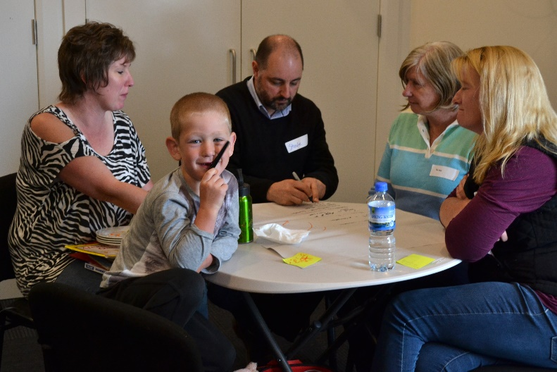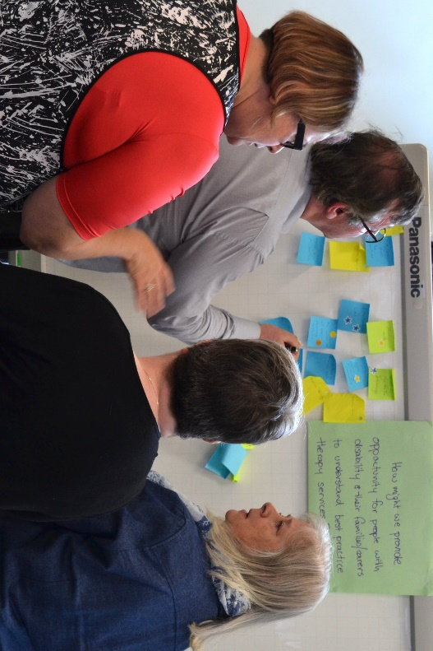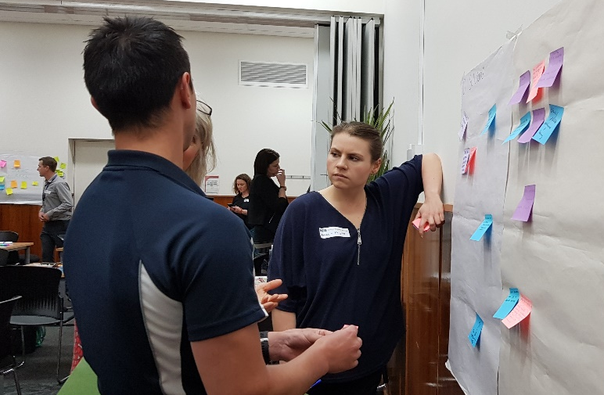
Funded by the Australian Government Department of Social Services

Background
There is a shortage of allied health practitioners (AHP) to provide therapy supports to people with NDIS plans in regional, rural and remote Tasmania. This, in conjunction with the expected increased demand for disability services in the coming years, poses a significant risk to the successful roll out of the NDIS in these areas, potentially impacting the quality of life for people with disability and developmental delay.
NDS has received NDIS Sector Development Funding from the DHHS, to develop and implement strategies to address AHP shortages and to increase the capability of the AHP support workforce to better meet the needs of people with disability and developmental delay residing in regional, rural and remote areas of the state. The following project outcome areas were agreed:
- Retention rates for existing AHPs in regional/remote/rural areas will be maintained or improved
- New AHP and other disability support professionals/support workers will be attracted into regional/remote/rural areas
- Allied Health Assistant (AHA) traineeships will be established
- An Allied Health Disability Workforce Strategy for regional, rural and remote Tasmania will be developed
As part of the project, community Forums were held in Smithton, Burnie, Scottsdale and Huonville to inform project priorities, and to identify place based supports in the delivery of allied health services. This report summarises the discussions and ideas generated in each of the four communities.
Following these community Forums, a separate Forum for allied health professionals was held in Campbell Town, see report on clinician Forum for further details.

How the Forums were run
NDS visited each community twice in the lead up, to gather background information, engage stakeholders and promote the Forums.
Each event ran for three hours and either morning tea or afternoon tea was provided. Venues were chosen based on accessibility and acceptance gauged from prior engagement. Three or more members of the project team were present for each Forum, to facilitate group discussion and activities and provide relevant input based on their background and expertise.
Timing of Forum activities was flexible depending on attendee responses to topics. Questions and reflective discussion were actively encouraged. The Forums were designed around the following topics, chosen through prior community engagement and pre-defined project priority areas.
- Allied health professional roles
- Positive behaviour supports & NDIS quality and safeguarding
- Allied health service mapping
- Issues identification – access to allied health services
- Solutions generation – access to allied health services
- Expression of Interest: Cert IV Allied health assistance traineeship
See Appendices 1 and 2 for further details about how the Forum was promoted and run.

Who attended the Forums?
Attendee numbers varied at each Forum, ranging from 27 in Burnie, to 10 in Smithton (see figure 1 below). Attendees were sorted into the following broad categories of stakeholders to provide an overview of people represented at each forum and also to allow for identification of priority issues by different stakeholders across all four forums.
- General community members
- Includes but not limited to local council representatives, LINC (library and IT services) staff, community/neighbourhood houses and general health services.
- Disability support providers
- Includes managers and team leaders from disability service organisations (DSO), disability support workers (DSW), and NDIA ‘linker’ roles such as local areas coordinators (LAC), early childhood early intervention (ECEI) partners, and community connectors.
- Advocates, families, people with disability
- AHPs / Allied health clinical managers
Figure 1 Community Forum attendees by community and category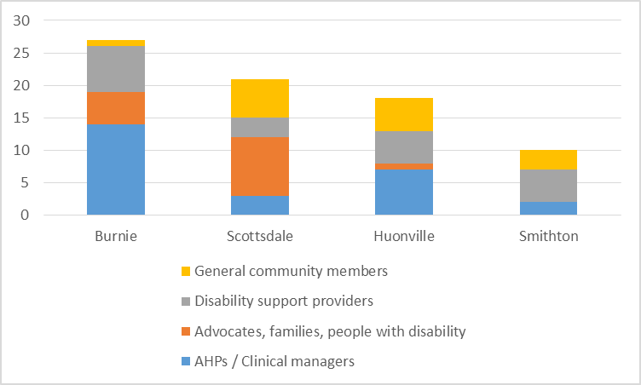
Efforts were made in all four communities to attract people with disability, their families and representatives through local networks and advocacy services. They were represented at all forums with the exception of Smithton. However it should be noted that many attendees identified under several categories (for example many community members also had family members with disability).
In spite of significant efforts to engage with NDIS local area coordinators (LACs) and Early Childhood Early Intervention (ECEI) partners in each community, none attended in Burnie and Huonville, and only one attended in each of the Smithton and Scottsdale forums.
Overall the Forums were well attended by a relatively broad representation of stakeholders, with variances in each community that at least in part reflected the local context, this is discussed in further detail in community specific sections of this report.

Overall issue themes
The issues reported in community Forums fall into the following nine broad themes (listed in no particular order).
- Lack of allied health and/or disability services in local community
- Difficulty navigating the NDIS
- Allied health services are not person centred
- Therapy services are fragmented
- Lack of supports for behaviour management
- Poor collaboration between AHP and local supports
- Lack of information about AHP availability
- Lack of knowledge on role of AHPs
- Lack of support for transport/travel to therapy services
These themes were drawn from common themes unearthed through all of the project consultation activities, and adapted slightly to suit the community context. See appendix 3 for details of overall project issue themes.
In each forum, attendees were provided with 6 voting dots to place against any of the issues they felt need to be addressed as a priority. Figure two provides an overview of voting against issue themes in each community.
Figure 2 Overall votes for key issue themes in community Forums
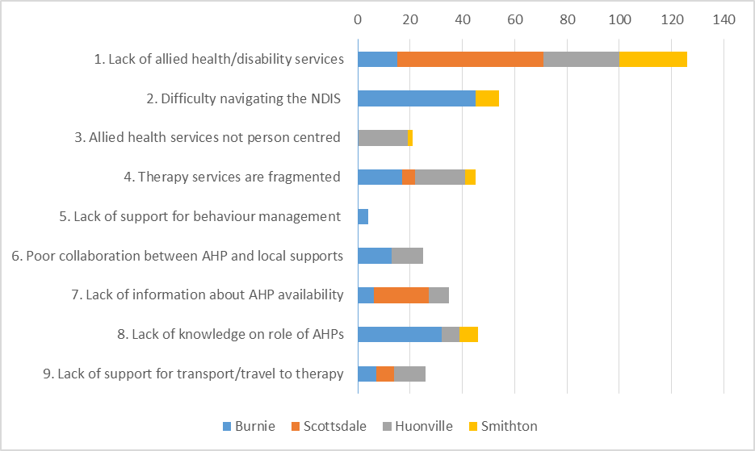

The overall top five issues from collated Forum data are listed below, in order of priority based on total votes received.
- Lack of allied health and/or disability services in local community
- Difficulty navigating the NDIS
- Lack of knowledge on role of AHPs
- Therapy services are fragmented
- Lack of information about AHP availability
As shown in figure 2, there are both similarities and differences in the prioritisation of issues between communities. The only two issues that came up in all four community Forums were lack of allied health and/or disability service availability and fragmentation of therapy services. Both of these issues were expressed differently in different communities according to the local context.
To provide further information on priority issues expressed by different stakeholders, attendees from the four main categories (as detailed on page 3) were provided with different stickers so that votes on issues could be tracked. The lack of allied health and/or disability services was the most voted for issues amongst all four stakeholder categories, however differences were found between different stakeholders for other priority issues.
Allied health professionals and their managers were the overall majority stakeholder group, accordingly their top five priority issues aligned well with the overall top five issues reported above.
In contrast to the overall votes, a lack of support to transport was represented in the top 5 issue for advocates, families, people with disability and general community members. This was reported both in terms of a complete lack of transport options and a lack of funding to access available transport in the community.
Additionally poor collaboration between AHPs and local supports such as DSWs, families and carers was represented in the top 5 issue by advocates, families, people with disability and disability support providers.
Appendix four provides a full breakdown of issue votes by stakeholder category.
The following section details the issues and solutions presented in each community Forum.

Community Specific Findings

Burnie Forum

Allied health service map
Burnie is a hub for both government and non-government health and disability services in the North West region of Tasmania, and the Forum was very well attended by AHPs and allied health managers. Accordingly the service map produced by Burnie forum attendees was the most allied health specific, the most detailed and contained the most services of all the Forums. In spite of this, significant confusion was expressed regarding the details of different services such as client target groups, skills sets of AHPs and ability to undertake outreach visits.

Issues
Unlike the other three Forums, it was difficulty navigating the NDIS, rather than a lack of services that rated highest amongst the issues reported in Burnie. This is unsurprising given it is a hub for services in the region.
The eight issue themes that received votes in the Burnie community Forum are shown in figure 3 below.
Figure 3 Votes received for issue themes in Burnie community forum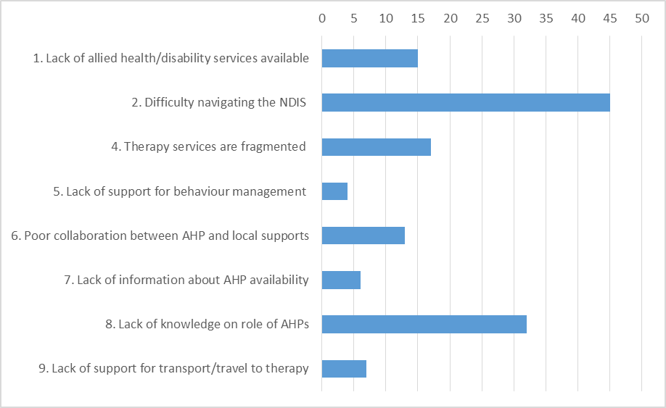
Frustration and confusion with the NDIS dominated discussion on the day, including difficulty with processes involved in accessing and navigating the scheme, and the rapid changes that are taking place. The interface between the NDIS and other services also came up, with the perception that there is a ‘tug of war’ over responsibility between different services that is complicating things further. This sentiment was also expressed to NDS during pre-Forum engagement in Burnie.
‘What you are saying (about the NDIS) is foreign to me, I don’t even know what you are talking about!’ (Attendee in response to discussion about NDIS processes)
‘Stop moving the goal posts!’ (Attendee talking about rapid changes with NDIS processes)
Several attendees expressed their concern at the lack of knowledge and experience of NDIS LACs and ECEI partners when it comes to allied health therapy services, with the perceived consequence that participants are not receiving well directed plans and are not being referred to an appropriate AHP to meet their goals. This concern surrounding a lack of knowledge regarding allied health was also noted for people with disability and their families and carers, impacting on their ability to request relevant AHP support in the planning process.
Fragmentation of therapy services rated next in the order of priority issues in Burnie. The backdrop to this focus on fragmentation is the pending loss of longstanding Burnie based government multidisciplinary allied health teams. Smaller private and not for profit allied health services will replace these coordinated teams as part of the NDIS roll out.
A lack of time to provide quality services under NDIS plans and poor collaboration between AHPs and the disability support workforce also came up during discussion. Particular reference was made to the varying skill levels of the disability support workforce, and the consequent difficulty in implementing therapy recommendations.

Solutions
Burnie Forum attendees chose to develop solutions for four of the identified themes as follows:

Therapy Services are fragmented
A single large organisation of skilled and experienced allied health professionals was the favoured solution. The need for adequate remuneration for skilled workers was noted to be of importance, perhaps reflecting the pending disbandment of some long standing government allied health teams with full scheme roll out.
‘Don’t throw out existing models that work’
Other ideas put forward included connecting a support coordination role more directly to allied health service providers, and supporting collaboration and information sharing between different service providers.

Lack of knowledge on what AHPs do (NDIS LACs/ECEI partners)
Keeping the status quo resonated strongly in this Forum. It was suggested that Early Childhood Intervention Services (an education department run service) should be made the NDIS ECEI partner organisation, instead of the current NDIS ECEI partner arrangements with Mission and Baptcare. Again the need for better remuneration was raised, with the suggestion that existing staff salaries, titles, and benefits should be retained as part of this solution.
The provision of more training and professional supports to existing LACs and ECEI partners, including more formal training opportunities, and mandated induction programs with allied health service providers was raised. It was also suggested that AHPs should be employed in these roles (again with adequate remuneration).

Difficulty navigating the NDIS
A draft plan review process, with opportunities for service providers and participants to provide input prior to finalisation of the plan was the favoured solution to this issue. It was noted that this would ensure the plan is correct the first time, preventing unnecessary stress to service providers and participants.
Other ideas focussed on managing the complexity and the rapidly changing nature of NDIS processes, including the development of ‘How to’ plain English fact sheets, and developing a website with relevant areas for service areas, include allied health professionals.
‘Make the system user friendly’
As per the previous theme, education for LACs/ECEI partners, or the attraction of more experienced professionals into these roles was suggested as a way to ease navigation of the NDIS.

Lack of knowledge on what AHPs do (people with disability, families and carers)
Solutions for this issue largely focussed on the provision of accessible information to participants. The chosen solution described a video depicting a goal directed discussion between a participant and planner, with segue to relevant AHPs describing how they might provide input into meeting goals.
Other favoured ideas included using easy English to provide information, and the presence of an advocate at the planning session.

Scottsdale Forum

Allied health service map
The Scottsdale service map was by far the most sparse of all four Forums, this is likely reflective of the different attendee cohort (less AHPs and disability service providers, more general community and families and people with disability), as well as a lower presence of allied health and disability services in Scottsdale compared with other communities.
Attendees tended to focus on the services known to them in the local community, regardless of their purpose or target client cohort. There are very few allied health services available in Scottsdale, most are either outreach services, or community members travel to Launceston to access them. Many attendees required prompting to include details on outreach allied health service providers, and were then unsure of what meant by allied health, who visits and how often. This reflected strongly in the issues discussed below.

Issues
A lack of services for people with disability was by far the highest scoring issue at the Scottsdale Forum. This was not limited to allied health services, in fact attendees reported a general shortage of disability supports such as support for personal care and community access/social supports. This was corroborated by NDS visits to the community prior to the Forum.
The four issue themes that received votes in the Scottsdale community Forum are shown in figure 4 below.
Figure 4 Votes received for issue themes in Scottsdale community forum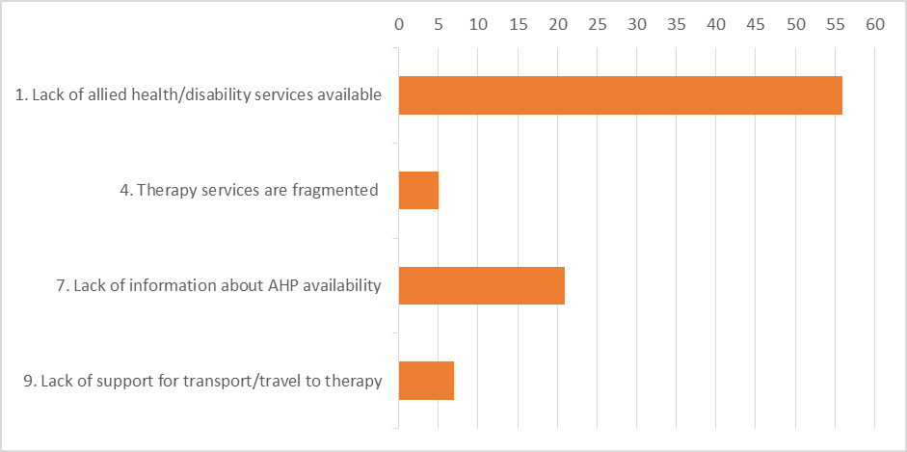
An older attendee detailed her caring role for her adult daughter with intellectual disability, and her struggle with the lack of services/supports they are receiving.
‘No-one has offered us services, we are completely on our own’
A strong sense of isolation was reported for people with disability and their carers/families in Scottsdale, it was further suggested that those living outside of the Scottsdale town centre are even more isolated.
There is a heavy reliance on visiting allied health services in Scottsdale. Fragmentation (lack of collaboration and coordination between providers) and wait times between outreach visits, were both issues that featured heavily in discussion. This was reported as a concern for all services, not just allied health.
There was significant confusion regarding the allied health providers that outreach to the Scottsdale community and how people might find out about these services. Included in this discussion was the lack of knowledge regarding what supports AHPs can provide, with one attendee noting:
‘As far as I am concerned you are speaking a different language, I don’t know about these people!’
The NDIS was not discussed in depth, as there was limited experience in the room with accessing the scheme. However one attendee detailed how her son with autism received significant funding through his NDIS plan for therapy services, but didn’t spend the money before the end of his plan as they were unable to access appropriate therapy services.
A number of local volunteers were present at the Forum, they expressed significant pride in their ability to support local community members in spite of a shortage of formal services.
Transport repeatedly came up as an issue for people in Scottsdale, many community members regularly make the trip to Launceston to access much needed services. Whilst local service providers and volunteer networks reported they do their best to provide support for transport, it was noted that they are stretched and gaps still exist. Additionally Forum attendees reported confusion as to what supports currently exist for transport.

Solutions
Scottsdale Forum attendees chose to develop solutions for two of the identified themes as follows:

Lack of services available in local community
Telepractice (the delivery of therapy and assessment at a distance through the use of technology) was identified as the top solution to address the issue of wait times arising from reliance on visiting outreach allied health and other specialist services. Whilst this was voted the top solution, it was acknowledged that not all services may be delivered this way, and that community members and service providers would need support to implement this in practice.
Other ideas included better information sharing around visiting services and options, improved networking between service providers and community, and supporting travel to Launceston to access services there.
Despite not being a focus of the project, attendees chose to address the lack of local disability support workers as this issue is being felt more acutely by some. The chosen solution to this issue was a register of local community members who are trained/interested in support work. It was further detailed that the community could keep a centralised list of worker availability and have a local matching/meet and greet night where clients/families could meet with potential workers. To support this bank of workers, it was suggested that training should be made locally available (including financial support), for example in gaining a certificate III in individual support (Disability) or community services. It was suggested that the local neighbourhood centre could apply for skills funding.
Isolation for people with disability, particularly those that are based in outlying communities surrounding Scottsdale, was also addressed. When attendees were asked how we might better connect these people to services, their solutions revolved around improved information sharing. Ideas for this included letter drops, the use of educational posters, community meetings and using the local neighbourhood centre.
This group also identified that many community members are not computer literate or are poorly connected to technology, as a result multiple modes of communication would need to be employed. This has implication for the chosen solution of telepractice, and indicates that concurrent support to improve digital literacy and IT infrastructure would need to be provided.

Lack of information about allied health service availability
Solutions under this theme tended to focus on improving and making better use of existing resources. The most popular solution involved updating the existing local council website with information about both visiting and local services. The local mayor was in attendance and indicated that he would support this initiative.
It was also identified that not all community members would access the website due to issues with technology access discussed above. Other ideas included an information booth or stand at the local information centre, holding a community function for visiting services, and placing a regular column in the local newspaper.
Another group emphasised the need for better coordination of information sharing initiatives, with the development of one communication strategy outlining a variety of actions. These could include the use of easy English information, and spreading the word via existing resources in the community such as school newsletters, local newspaper, and doctor’s notice boards. This would all then link to a central data base of services that is kept up to date.

Huonville Forum

Allied Health Service Map
The Huonville service map included many local services known to attendees, and lacked differentiation between allied health and other health and general community services. Attendees tended to have good knowledge of locally based services, perhaps due to the Huon Valley service provider network that is very active in the area.
Attendees required prompting to include visiting disability allied health service providers, and were unsure of the details on who visits and how often.

Issues
Whilst it was broadly acknowledged that Huonville and the surrounding Huon valley already has a strong and well-connected network of local service providers, many people with disability or development delay in the region reportedly travel to Hobart to access skilled AHPs, or must wait for outreach visits.
The eight issue themes that received votes in the Huonville community Forum are shown in figure 5 below.
Figure 5 Votes received for issue themes in Huonville community forum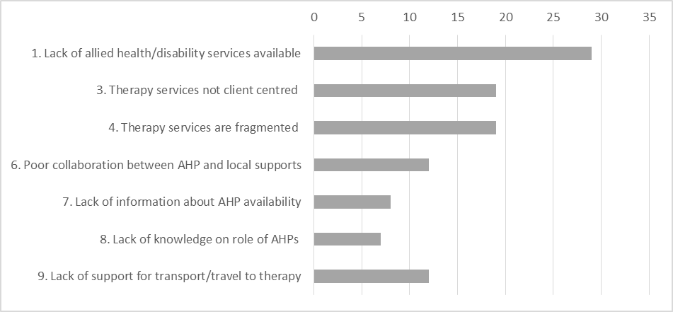
‘People are geographically isolated from allied health services’
Difficulty with recruitment of AHPs to work in the local community was highlighted, and the importance of knowing the local context when it comes to service delivery was also raised repeatedly in discussion. During engagement activities prior to the Forum, a worker from a local Aboriginal association suggested that there are several families in the Cygnet area that have never accessed formal disability support or allied health services, and are ‘not on the radar’ of the NDIS.
As with other Forums, fragmentation of therapy services (reported here as a lack of communication/collaboration between service providers), rated highly amongst priority issues. There were also reports of reduced efficiencies and double ups within organisations servicing the area. Attendees reported difficulty with finding and sorting through information regarding allied health service availability.
‘Services are overlapping and complex’
Another strong theme in Huonville was the lack of client centred allied health services, with acknowledgement that the medical model does not fit well with the social model of disability. This came as a surprise to several AHPs attending, one stated they assumed that all AHPs are a ‘friendly face’ for people with disability.
‘People with disability don’t feel welcome or understood by AHPs’
It was felt by some that a lack of collaboration between AHPs and the regular support network for people with disability may contribute to the issue above.
‘AHPs don’t know the whole picture’
Transport was again a strong theme which is unsurprising given the suggestion that many are travelling to Hobart for services. The lack of funding support for transport available through the NDIS dominated discussion on this topic.

Solutions
Huonville Forum attendees chose to develop solutions for the following issue themes:

Lack of allied health/disability services available in local community
Attendees in this group chose to focus their attention on the recruitment of AHPs in general. The most immediate solution identified was to train/up-skill support workers to work with AHPs. Whilst it was acknowledged this would not increase the supply of AHPs, it would improve therapy effectiveness and reach through improved collaboration with existing supports. It was also suggested that support staff should be better paid to improve retention and to attract better quality workers.
This group determined that the most important factor affecting the supply of AHPs in Tasmania is the lack of local options to gain undergraduate qualifications in several in demand professions (physiotherapy, occupational therapy, speech pathology and podiatry are only available interstate currently). It was suggested that University of Tasmania should work with interstate universities to deliver training locally, and that allied health student placement opportunities should be organised in local communities.

Therapy not client centred
Empowerment approaches dominated this discussion, the chosen solution involved placing people with disability on committees and boards in order to become more active citizens. Another suggested approach was the delivery of disability awareness training for AHPs, including training for specialist skill sets in disability such as behaviour management.
This group felt that communication skills are key, and identified the need for AHPs to adopt person centred communication skills as in addition to strategies to better link clinicians and families.

Therapy services are fragmented
The development of a clear pathway for communication was the chosen solution for this issue. This was described in two parts: a list of current local providers that is accessible and easy to locate, and one centralised template that all providers can use to communicate with each other, with a single release form for clients to sign was also suggested.
Other ideas included using support coordinators to arrange meetings for the professional team, case conferencing via skype, and NDIS payment of non-facing client time to ensure people are able to spend the time to communicate with each other.

Lack of support for transport/travel to services
Again empowerment/strength based approaches dominated discussion. The chosen solution involved supporting people to solve their own transport issues, by including transport as a goal in the planning process. Examples included the provision of supports for participants to gain their own drivers licence, and participants pooling their resources with other participants through the use of social media platforms so that they might coordinate appointments.

Smithton Forum

Allied Health Service Map
Unlike the other three forums, Smithton attendees were provided with a framework from which to draw their service maps. This included the following categories of service delivery: the use of technology options to access services, responsive outreach services who come to the local community from elsewhere, responsive centre based services for which people must travel to access, and innovative local solutions.
Almost all of the identified allied health services for people with disability and developmental delay were outreach from Burnie which is a hub for services in the region. Several innovative local solutions to the lack of local specialised services were also identified in this activity, however in contrast very few technology options for service access were identified.
As in Huonville, the Smithton service map included many local services known to attendees, and lacked differentiation between allied health and other health and general community services.

Issues
The sense of isolation for people with disability and developmental delay and their families came through strongly in Smithton. Forum attendees acknowledged that allied health services for people with disability and developmental delay are not readily available in the region. Those that are available are provided by outreach from other communities such as Burnie and these visits are often sporadic and infrequent. Otherwise people from Smithton must travel to Burnie or further afield to access much needed services.
The five issue themes that received votes in the Smithton community Forum are shown in figure 6 below.
Figure 6 Votes received for issue themes in Smithton community forum
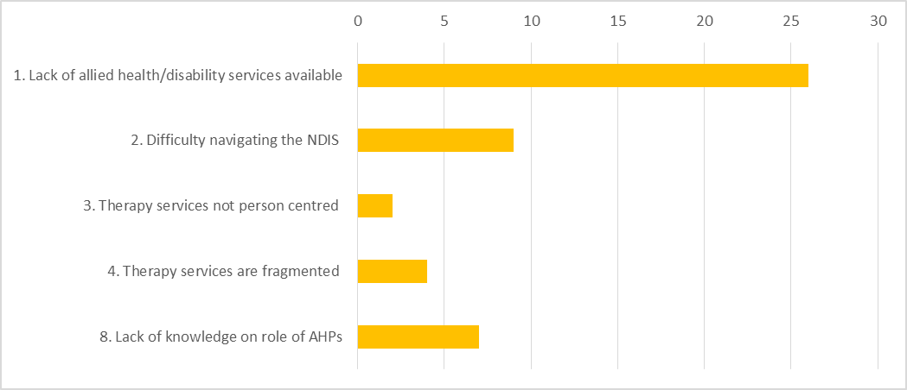
Note: In the Smithton Forum theme 8: Lack of knowledge on the role of AHPs was grouped together with theme 7: Lack of information about AHP availability.

Recruitment and retention of AHPs to work within the local community was valued by attendees, but acknowledged to be challenging.
‘We need people in these role who actually want to be in our community’
NDS has also previously met with workers at a local aboriginal organisation (who were unable to attend the Forum), who reported great difficulty with accessing skilled AHPs to complete assessments and make recommendations to support clients to access funding for supports through their NDIS plans.
Significant pride was expressed by attendees regarding the quality of local service providers in Smithton, and their ability to support community members by being responsive and flexible in the way they deliver their services. One attendee who works for a local disability support provider detailed how they continue to provide support for community members to access the local heated pool, so they can attend group exercise sessions. This is in spite of the fact that the AHP who previously supported the initiative no longer attends the community.
‘We do it all, whatever is needed!’ (Employee of a local disability support provider)
The gap in allied health services available to older people with disability including teenagers and adults was raised as a significant issue in the area with the acknowledgement that there are more options for young children with disability and developmental delay.
Navigating the NDIS was also identified as a priority issue. As discovered in other Forums, confusion exists around the interface of the NDIS with existing local services such as education and health. The long wait time and processes involved in approval of specialised equipment was also noted as an additional source of frustration by several attendees.
Some attendees expressed that NDIS planners lack understanding of the family situation and context of people with disability in their local community, which may impact on the quality plans and support services needed.
The issue of fragmentation was described in Smithton as a lack of collaboration between visiting AHPs and local service providers, who know the local context and client well, the issue of AHP services not being client centred was linked to this.
It was reported that people with disability and their families not only have difficulty knowing what allied health services are available to them, but may lack the knowledge and experience needed to identify when they are needed and then advocate for services.

Solutions
Smithton Forum attendees chose to develop solutions for the following issue themes:

Lack of allied health/disability services available in local community
As in Scottsdale, telepractice was voted the top solution to address service wait times and gaps, given that outreach services are infrequent and travel to services is difficult. Again, on the proviso that supports are provided to make this viable.
Other popular ideas included ensuring that referrals are properly directed in the first place (to reduce wait lists), and the addition of drop in clinics to assist in accessing appropriate referrals to services.
It was noted that there is already an allied health drop in clinic at the local hospital once a month, however attendees believed this is only available to children.

Lack of knowledge on what AHPs do and how to access them (combination of two themes)
The chosen solution for this idea was a ‘one stop shop’ for community members to drop in and receive information and supports in whatever area they need help. As per the pride in local services detailed above, one attendee stated that her service already does this really well.
Other ideas raised included the implementation of initiatives to improve the health literacy of the community at large. It was suggested this could include supporting community members to develop advocacy skills, and sharing knowledge between community members regarding what has worked well for others. It was also suggested that training could be provided for local service providers/visiting AHPs in how to provide information in a more accessible way.
Improved collaboration between visiting AHPs and local service providers was also noted to be of importance by this group.

Summary
Strong engagement was achieved in each of the four communities, which indicates that community members recognise the importance of supporting better access to allied health services for people with disability and developmental delay in their region.
There is an overall sense that access to allied health services for people with disability and developmental delay in these communities is limited, and poor connections between these services and local community supports and other services further compounds this issue.
It is clear that the implementation of the NDIS is presenting a significant challenge to local service providers and community members. Processes are changing, and are reportedly confusing and difficult to navigate for many stakeholders. This issue was expressed particularly strongly by allied health service providers that have been delivering services to people with disability and developmental delay for some time, and are now navigating these changes.
A general lack of exposure to, and knowledge about what AHPs can do to support people with disability and developmental delay came through in all four forums. Accordingly there was a call for more education around what role AHPs can play in providing supports to people with disability and developmental delay. This was expressed as a need not only for people with disabilities, families and support teams, but also to those involved in developing and approving NDIS plans.
All four Forums emphasised the need for stronger connections between AHPs (both local and visiting) and other local service providers. This included local disability supports, other AHPs and general health and education services in the community, amongst others.
Better utilisation and coordination of existing resources was a recurring theme. Particularly with regards to better communication and information sharing between service providers and community members regarding the NDIS and availability of allied health services.
Interestingly, telepractice was a popular solution for allied health access issues in both Smithton and Scottsdale, both of which are less connected to allied health services when compared with the other two communities. This came with the caveat that supports would need to be provided to develop IT infrastructure and digital literacy levels of local community members.
There are significant differences between each of the communities when it comes to existing service options and local supports, as well the issues experienced. Accordingly solutions should be placed based so that they are appropriate for the local context.

Next Steps
The community Forum findings will be used to inform the development of a Tasmanian Regional Rural and Remote Disability Allied Health Workforce Strategy and Action Plan, along with findings from the Clinician forum. This will allow the prioritisation and implementation of project activities until project end (end of June 2018), and application for further funding to extend project activities.
The workforce strategy and action plan will be shared with forum attendees and project stakeholders in early 2018, with encouragement to contact NDS to provide feedback.

Appendices

Appendix 1 Forum promotion

State wide/general contacts
- NDS members and project reference group
- Mission Australia & Baptcare NDIS teams
- Tasmanian contacts for Allied Health Professional Associations
- NDIA
- Association for Children with Disability (ACD)
- Tasmanian Council of Social Service (TasCOSS)
- Education department (disability team)
- Department of Health & Human Services
- Autism Tasmania
- Speak Out
- Advocacy Tasmania
- THS health promotion newsletters
- MS Society
- University of Tasmania
- Huntington’s Disease Association
- Tascare
- Nexus
- Health Recruitment Plus
- National Disability Coordination Officers –
- LiVe
- Motor Neurone Disease Association
- Primary Health Tasmania
- Down Syndrome Tasmania
- Guide Dogs Association
- Able Australia
- Oak Possability
- Anglicare
- Life without Barriers
- Independent Living Centre (ILC) regional contacts and management
- St Giles regional contacts and management

North West (Burnie, Smithton and surrounds)
Visits: 22nd - 24th August, 2nd - 5th October. Contact made with the following stakeholders:
- Rural Health Tasmania
- Burnie City Council
- Circular Head Council
- Life without Barriers
- Tasmanian Health Service NW
- Speech Pathology Tasmania
- Cocoon Paediatrics
- Suzanne Finn Speech Pathology
- Circular Head Aboriginal Corporation
- Oak Possability
- ECIS Burnie & Smithton
- Child and Family Centre Burnie
- Vincent Industries
- Family Based Care
- Local schools
- NW Residential Support Services
- Giant Steps (Autism school)
- Glenhaven
- North West Kids Occupational Therapy
- Multicap
- Speak Out
- Disability Assessment and Advisory Team (DAAT) North West
- Wyndarra (Smithton)
- Community House Smithton and Burnie
- Burnie & Smithton LINC
- ACD NW
- Mission Australia LACs/manager
- Coastal Physiotherapy
- THS health promotion
- Eskleigh foundation
- Leap Occupational Therapy
- Psychology Caffe
- SPAN (visiting service provider network based in Smithton)
- Family Based Care Association North West
- NW Child Development Unit
- Autism Specific Early Education & Learning Centre

Scottsdale
Visits: 25th August, 10th-11th October. Contact made with the following stakeholders:
- Dorset community house
- Dorset council
- LINC
- Max employment
- Scottsdale hospital (NESM)
- Scottsdale doctors surgery
- Speak Out
- DAAT (North)
- May Shaw Day Centre
- Bridport Child Health and Parenting Centre
- Storm Disability Services
- Wardlaw & Brown consulting
- RAW mental health outreach worker
- Royal flying doctors service
- Dorset Health and wellbeing group
- Integrated living
- St Michaels
- New Horizons (volunteer network)
- Local schools
- Visiting private dietitian, physiotherapist and psychologist

Huon Valley
Visits: 29th August, 16th & 17th October. Contact made with the following stakeholders:
- Huon Disability Network
- Oak Possability
- Parkside
- Huon Valley Council
- Huonville LINC
- Huon Physiotherapy
- Huon Regional Care
- Huon Valley Service Providers Network lunch
- Wayrapatee Child and Family Centre (Geeveston)
- Geeveston community centre
- South East Tasmanian Aboriginal Corporation
- Huon community health centre
- Southern support school
- DAAT south west
- Rick Baxter Consultancy
- PANDA therapy
- Speech Pathology Tasmania
- LEAP health
- Wise employment
- Community Based Support
- Cygnet Family Practice
- Huon Doctors Surgery
- Health Strong
- Dover medical centre
- Geeveston Medical Centre
- Independent Kids

Appendix 2: Structure of forum activities

Allied health professional roles
Purpose:
- To bring attendees to topic at hand and gauge exposure and knowledge regarding AHP roles
Activity:
- Different AHP names placed up on walls, attendees were asked to write a story about what each AHP does on post it notes and place on relevant AHP
- Reflective group discussion leading from this was based on attendee input

Positive behaviour supports & NDIS quality and safeguarding
Purpose:
- Provide introduction to positive behaviour supports and NDIS Quality and Safeguarding framework
- Provide information on training in implementing behaviour support plans planned in 2018
Activity:
- Overview provided by NDS, followed by reflective group discussion based on attendee response

Allied Health Service mapping
Purpose:
- Gather information about existing allied health services and gaps, and gauge awareness of availability of the allied health supports available in each community
Activity:
- Groups were instructed to draw a map of allied health services for the local community, for three age groups: 0-6 years, school aged and adults.

Issues Identification – access to allied health services
Purpose:
- Identify the issues people with disability and developmental delay in community experience with accessing allied health services
Activity:
- Table discussion re issues with accessing allied health services in local community (scribed)
- Each table provided summary of issues to group, which were scribed by project team
- Each attendee provided with 6 voting dots to allocate to any issues that they think need to be addressed as a priority (max three dots allowed per issue).
- Top issues were then chosen based on group vote and consensus

Solutions generation – access to allied health services
Purpose:
- Identify place based solutions to most pertinent issues being experienced by community
Activities:
- Brief activity aimed at engaging creative brain and opening minds prior to solutions generation
- Attendees chose the issue they would like to work on from those identified in the previous activity.
- Silent brainstorm for solutions, encouraged ‘blue sky thinking’ and as many ideas as possible
- In group: review and theme solutions in order to refine them, then vote on top 5 ideas (sticker dots)
- If time allowed, groups were then asked to evaluate ideas on a matrix, low to high cost, then low to high impact. This assisted them to critically review their idea and choose their top solution.
- If still time left, groups were asked to provide detail on their chosen solution.

Expression of Interest: Cert IV Allied health assistance traineeship
Purpose:
- Gather details of parties interested in undertaking or discussing the cert IV traineeship opportunity to follow up at a later date
Activity:
- A flyer was provided detailing the Cert IV AHA traineeship opportunity, and a brief discussion was held regarding the use of AHAs to extend therapy reach.

Appendix 3: Issues for AH service delivery in Tasmania for people with disability and developmental delay
Table 1 Issue themes and breakdown
Issue | Break down
Difficulty with recruitment and retention of AHPs in the disability sector in Tasmania (state-wide). | - Difficulty attracting new professionals into the disability sector  - NDIS funding model not allowing for training/support of new professionals including student placements and new professionals entering the sector  - Lack of Tasmanian undergraduate degrees in SP, OT, PT, O&P and Podiatry  - Attrition of existing AHPs who work in government teams, not willing to take risk of starting new business or willing to take lesser pay at not for profits  - Lack of recognition of AHPs with higher skills levels/more experience in NDIS pricing (lack of clinical career path/progression), which means there is less incentive to remain in sector compared with other areas such as the health sector
Lack of allied health service availability for people with disability and developmental delay in rural and remote areas | - Sense of isolation reported by people with disability and their families living in rural and remote areas, expressed in terms of connectedness to services and supports  - Visiting providers are infrequent and irregular = poorer access and longer wait times for people in more geographically isolated areas  - General lack of choice of providers who are based locally, some community members have expressed a preference for local providers where that option exists  - Visiting providers don’t understand the context in which they are working  - AHPs not willing to live and work in rural and remote areas for a variety of reasons including lack of stable employment options and services  - Thin markets – regular outreach not viable for therapy providers due to insufficient funding and resources available  - Poor links between visiting providers and local supports
Gaps in allied health service delivery | - Poor data and clarity around where the demand and need is, in order to best direct service delivery  - Less allied health services available to school aged and adult people with disability  - Specialised skill sets such as paediatric physiotherapists often not available or limited to urban areas
Difficulty navigating the NDIS | - Poor understanding the concept of the NDIS and processes involved – service users, AHPs, disability support workforce, general community and other service providers such as health and education  - Perceived lack of communication from NDIS regarding processes and changes  - Delays and issues with payment for services reported by service providers.  - Complicated planning and implementation processes, increased admin and wait times reported by both service providers and service users  - Poor accuracy of plans, planners/Local Area Coordinators (LACs) & Early Childhood Early intervention (ECEI) partners failing to understand context of person with disability or developmental delay  - Lack of clarity on interface between NDIS and other services, particularly education and health, and what NDIS will fund  - Difficulty with registering new providers
Available allied health services aren’t always person centred or appropriate for people with disability and developmental delay | - ‘Medical model’ not fitting with social model of disability  - Lack of governance for quality of services particularly private providers new to the space  - Concerns around vulnerable clients not receiving good quality therapy supports  - AHP not understanding the concept of capacity building for clients  - AHP not understanding context of participant’s life  - Organisational culture and structure of AH services not always supporting person centred service delivery
Fragmentation of allied health services | - Loss of larger multi-disciplinary government disability teams (in progress with disbandment of DAAT teams and possibly Early Childhood Intervention Services), proliferation of small and sole providers, resulting in loss of professional networks for skills sharing and collaboration  - Loss of information history when client leaves a service  - NDIS framework leading to decreased coordination & fragmentation of services.  - Complex/more vulnerable clients are not funded at appropriate levels
Lack of appropriate supports for behaviour management | - Not enough training for provision of Positive Behaviour Supports  - AHPs, DSWs, AHAs, carers/families, disability service provider managers  - Poor awareness, management and reporting of restrictive practices
Lack of access to CPD and training for AHPs in disability sector | - Billable hours requirements under NDIS funding model not allowing for release time for CPD and training required for AHPS to work effectively in the sector  - General lack of training/CPD availability for regional rural and remote AHPs  - Lack of disability specific CPD/support availability for both new and more experienced AHPs in the Tasmanian disability sector.  - Disability specific clinical information and resources are difficult to find/poorly coordinated
Lack of support for effective working relationships between AHPs and disability support workforce | - Poor communication and collaboration between AHP and support staff due to a number of factors including insufficient time, inappropriate models of practice & relationships.  - Lack of staff and high turnover of disability support workers (DSWs), NDIS funding model does not allow AHPs time/flexibility to manage issues with this.  - Poor training and literacy levels of DSWs, impacting on their ability to implement therapy recommendations  - Fear from AHPs surrounding the inappropriate use of allied health assistants (AHAs) – going beyond scope poor quality of services.  - Time for training and supervising AHAs and DSWs is not funded adequately, inadequate risk management for liability and legal issues when delegating tasks
Lack of information about allied health service availability | - People with disabilities and developmental delays and families and carers, LACs, ECEI partners, support coordinators & other AHPs  - Information is fragmented and difficult to find
Lack of knowledge on AHPs’ role in supporting people with disabilities and developmental delays | - Families and carers, people with disability, LACs, ECEI partners, support coordinators  - Results in therapy need not being recognised (not referred) or poorly directed referrals to allied health services
Lack of support for transport/travel to allied health services | - Cost and time involved is not funded  - Increased pressure on families and services
Poor infrastructure and skills in use of technology | - Poor internet connection in rural and remote areas  - AHPs, people with disabilities/families/carers, disability support workforce not skilled in use of technology  - Lack of existing infrastructure and skills for use of telepractice options for delivery of therapy supports

Appendix 4: Issue themes breakdown by attendee cohort
Figure 7 Overall % votes by attendee category per each issue theme
