NDP Sole Trader Handbook
Costs of Services and Forecasting
Business Essentials
ndp.org.au/ndis-sole-traders

Introduction
The NDIS offers a new way of providing individualised support for people with disability, their families and their carers by giving them more choice on what supports they need, and how they are provided.

If you work for a disability service provider, your employer is likely to have already undertaken the preparations needed to operate under the NDIS. If you are providing services as a sole trader or in a private practice, it is critical to understand the NDIS market.

We know that it is sometimes hard to find the information you need, so we have done the hard work for you! We have worked with accountancy and consultancy firm Nexia Australia to collate publicly available information and resources to support your journey of working with the NDIS.
Date of publication: July 2018

Disclaimer:
The information contained in this handbook is not provided as advice or as recommendations.

The information is intended as a general guide only. It does not take into account your personal circumstances and may not be relevant to you or be fully up to date. You must rely solely on your own external and independent advice.
The information provided should not take the place of information or advice available from, or provided directly by, relevant Government bodies, including the National Disability Insurance Agency (NDIA) and the NDIS Quality and Safeguards Commission (NDIS Commission).
While we endeavour to keep advice up to date and correct, National Disability Practitioners (NDP), a division of National Disability Services Limited (NDS), cannot be held responsible for the accuracy of the information, or any other matter arising out of the use of the information appearing on the site.
The ‘NDIS & Sole Traders’ project is funded by the Industry Development Fund, delivered by National Disability Services on behalf of NSW Department of Family and Community Services: Ageing, Disability and Home Care.

Contents
Introduction........................................................................................1
Costs of service and income forecasting...........................................4
Scenario planning..............................................................................7
Costing and revenue analysis tool.....................................................8
Debtor management..........................................................................9
Managing cashflow...........................................................................10

Costs of service and income forecasting

Price, Cost, Income, Expenses and Profit Explained
- Price: amount a customer pays for a product or service.
- Cost: expense that a business incurs to produce a product or to carry out a service.
- Income: total amount earned in a given period of time.
- Expenses: total amount spent in a given period of time.
- Profit: difference between the total amount earned and the total amount spent in the same period of time.

Beware of Hidden Costs
Typical business costs, such as wages, insurance, travel costs, rent and utilities are straightforward and easily identifiable. Small business owners can easily budget for such costs.
Other costs may be “hidden”. Small business owners should pay attention to these hidden costs which may have significant impact on the sustainability and profitability of your business.
Common hidden costs include but are not limited to:
- Bad debt: may arise when a customer refuses or is unable to pay for a service.
- Cancellations and no-shows: When a customer cancels without sufficient notice, you may have incurred costs such as travel or wages, and you may not be able to recover the potential income from the cancelled appointment.
- Compliance cost: for example, the cost of the third-party verification in order to register as an NDIS provider in NSW.
- Management cost: Most owners of small businesses need to spend considerable time to manage their business. Management duties may include business planning, record and financial bookkeeping, marketing and business development, bookings and scheduling, and dealing with regulators and the government (e.g. NDIA audits). While this is not a direct cost, management duties reduce business owners’ capacity to see clients and generate income.
- Opportunity cost: a benefit that a person could have received, but gave up, to take another course of action. For small business owners, salaries from employment would be an opportunity cost for choosing to operate your own business.

How to Set Prices
You can follow these steps to set prices for the services you provide:
- Work out your cost (e.g. for an hour of each type of service) (A)
- Determine a target profit margin (B%)
- Check the price limits set by the NDIS (if applicable) (C)
- Find out the average price your competitors are charging in the local area (D)
Price = A x (1+B%)
Price must be equal to or less than C, if NDIS price limits apply.
Price should not be significantly greater than D, unless you can justify charging your customers a premium.

NDIS price limits
The National Disability Insurance Agency (NDIA) sets out the maximum prices that registered providers can charge NDIS participants for most services funded by the NDIS. Although your business may not be an NDIS registered provider, the price limits would still apply if you work with NDIS participants who use a plan manager (or financial intermediary) to pay NDIS bills.
NDIS price limits are based on either “per hour” or “per unit” measurements.
Visit NDIS website for the latest Price Guide, which includes price limits for most commonly used NDIS support items.
The NDIS Price Guide is updated at least once a year in July. Make sure you have access to the most up-to-date version of the NDIS Price Guide.

Income Forecast
Forecasting business income during the startup stage can be difficult for many small businesses. Building forecasts with any degree of accuracy requires a lot of time, effort, and potentially paid assistance from an accountant or bookkeeper. But income forecasts are crucial. Robust income forecasts will help you plan for your business’ operation and growth, and more importantly, give yourself confidence and peace of mind by reducing the stress from uncertainty.
You can follow these steps to begin developing an income forecast:
- Determine the price(s) of your service with reference to NDIS price limits (A)
- Work out your maximum productive capacity in a given period (e.g. 8 hours a day x 5 days a week x 44 weeks = 1,760 hours in a year) (B)
- Estimate planned downtime (non-productive time) in the same period. This would include time allowed for management duties, non-recoverable travel time etc. (C)
- Determine a “safety margin” to allow for unplanned downtime due to insufficient client bookings, no-shows and cancellations and other unforeseeable circumstances (D%)
Forecast Income = A x (B – C) x (1 – D%)

Scenario Planning
Scenario planning, sometimes referred to as “contingency planning”, is a useful way for small business owners to think about and plan for the future.
Developing an income forecast only gives you one view of the financial future of your business (“the base scenario”).
Business owners need to develop additional forecasts to plan for “the best-case scenario” and “the worst-case scenario”.
The best-case scenario should be a projection based on the best possible assumptions, for example, the best possible growth in demand for your service and minimal unplanned downtime. The best-case projection should be used to test the capacity limit of your business, i.e. would your business sustain a higher than anticipated growth? For example, if you are overbooked, can you find other workers to fill the additional shifts (appointments)?
The worst-case scenario should be a projection based on the worst possible assumptions, for example, the worst possible decline in demand for your service and maximal unplanned downtime.
The worst-case projection should be used to test the financial resilience of your business, i.e. would your business sustain a significant downturn? For example, if you receive no bookings, how many weeks will the business last without initiating “Plan B”, and what is your “Plan B”?
Realistically, business owners are likely to land somewhere between the best-case scenario and the worst-case scenario. Having planned for both extremes will enable you to know your limits and have strategies in place to deal with unplanned growth or stagnation.

Costing and Revenue Analysis Tool
What is a costing and revenue analysis tool?
The Services Costing and Revenue Analysis Tool provides cost estimates for the types of services provided by an organisation. It is designed to allow users to clearly identify the linkages between activities offered and the costs associated with them. This tool will allow an organisation to plan the services they can deliver within a given set of resources.

Who would use a costing and revenue analysis tool?
Both sole traders and small businesses would benefit from utilising a costing and revenue analysis tool.
A NDP Costing Tool template is included.
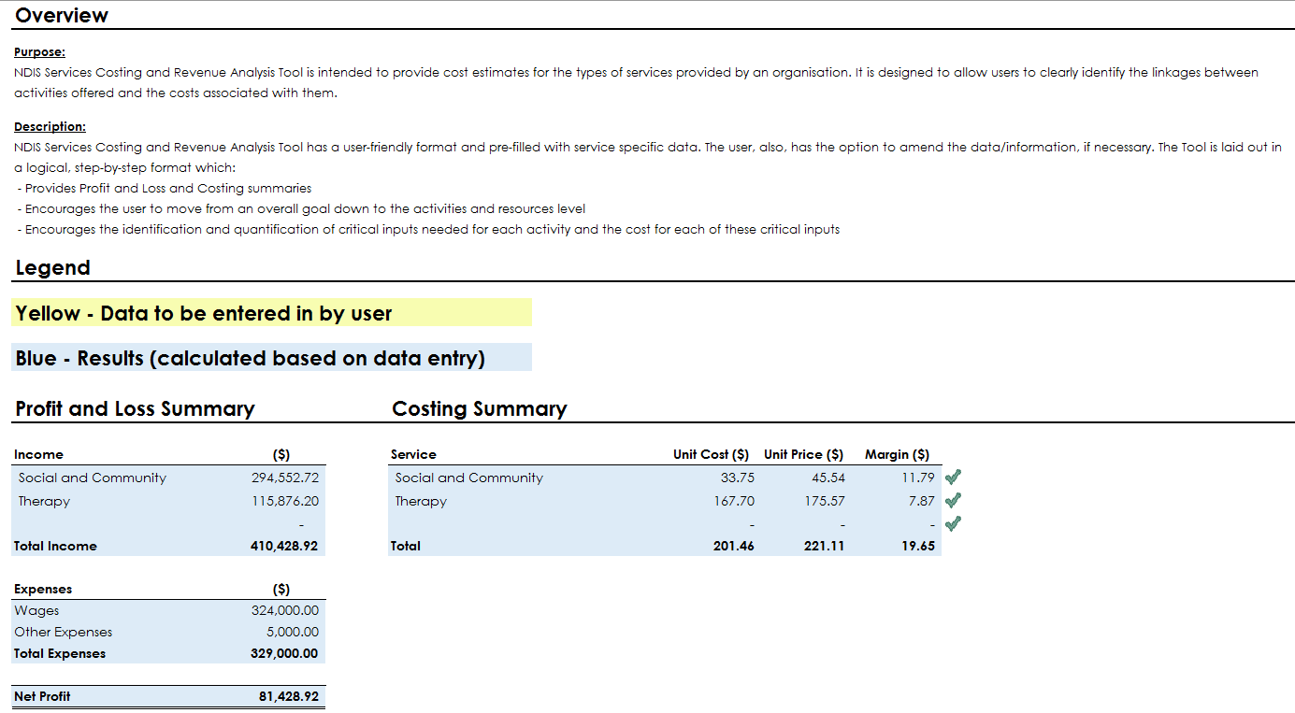

Debtor Management
A debtor is a person or an organisation who has used your service and has not paid for the service.
All accounting software, when used properly, will be able to help you keep track of who your debtors are and the amounts they owe you. If you do not use any accounting software, you need to keep clear records of your debtors and regularly update these records.
A bad debt is an amount that cannot be collected from a debtor. Generally, bad debts can arise when your customer bankrupts, dies, becomes uncontactable or disputes the liability. Specifically, bad debts from NDIS participants could be due to insufficient funding in a participant’s NDIS plan, invalid or expired NDIS Service Booking(s) or supports deemed unnecessary or unreasonable by the NDIA.
Bad debts, once recognised, would be written off in your accounting records and deducted from your income for accounting and taxation purposes.
How to Minimise Debtors and Avoid Bad Debts
Small businesses can take one or more of the following measures to minimise debtors and avoid bad debts:
- Bill your customers, claim from the NDIS portal, or bill your customers’ financial intermediaries (plan managers) as regularly as possible – generally no longer than 2 weeks after the service;
- Send reminder statements to your debtors at least once a month;
- Resolve any claiming or payment issues as soon as possible with the NDIS, your customers or their financial intermediaries;
- Offer multiple payment methods to make it easy for customers to pay you;
- Ask for prepayment or immediate payment after service from high-risk customers (may not always be possible); and
- Have clear terms and conditions including payment terms (commonly 7-14 days for small businesses) written in the service agreements with all customers.

Managing Cashflow
Cash is king for all businesses, especially small businesses. Profit is required for ultimate success, while cash is required for immediate survival.
Ideally, your business’ monthly cash inflow should be greater than your monthly cash outflow.
- Cash inflow mainly consists of customer fee payments (including claims from the NDIS);
- Cash outflow may include wages, other creditors, rent, business or vehicle loan repayments (principal and interest), capital purchases and your own drawings.
Small businesses can take one or more of the following measures to manage cash outflow:
- Take full advantage of creditor payment terms;
- Consider payment terms when choosing suppliers;
- If you can rent, don’t buy;
- Consider adequacy of working capital when you draw funds from the business to pay for personal expenditure;
- Plan for capital expenditure in advance; and
- Consider introducing partners or co-investors when planning for business expansion.

Contact us:
National Disability Practitioners
T: 02 9256 3188
E: info@ndp.org.au
W: http://www.ndp.org.au
Facebook: /NationalDisabilityPractitioners
Linkedin: /national-disability-practitioners
Twitter: /NDPbuzz
Instagram: /ndplife

